Main Manuscript for
Highlighting epistemic uncertainty in rain-on-snow processes during California’s Oroville Dam flood of February 2017
Kayden Haleakala* (1), W. Tyler Brandt (2), Benjamin J. Hatchett (3), Dongyue Li (4), Dennis P. Lettenmaier (4), Mekonnen Gebremichael (1)
(1) Department of Civil and Environmental Engineering, University of California Los Angeles, Los Angeles, California;
(2) Center for Western Weather and Water Extremes, Scripps Institution of Oceanography, San Diego, California;
(3) Division of Atmospheric Sciences, Desert Research Institute, Reno, Nevada;
(4) Department of Geography, University of California Los Angeles, Los Angeles, California
*Corresponding author: Kayden Haleakala
Email: khaleakala@g.ucla.edu
Address: 5732 Boelter Hall, Los Angeles, CA 90095
PNAS Nexus strongly encourages authors to supply an ORCID identifier for each author. Do not include ORCIDs in the manuscript file; individual authors must link their ORCID account to their PNAS Nexus account at https://pnasnexus.msubmit.net/cgi-bin/main.plex. For proper authentication, authors must provide their ORCID at submission and are not permitted to add ORCIDs on proofs.
Author Contributions: KH, WTB and BJH designed research, KH, DL, and WTB performed research and analyzed data; KH and WTB wrote the paper, BJH, DPL, DL, MG provided revisions, MG supervised the project.
Competing Interest Statement: The authors declare no real or perceived conflicts of interest.
Classification: Physical Sciences – Earth Sciences.
Keywords: flood, rain-on-snow, Oroville Dam, terrestrial water input, observation

This PDF file includes:
Main Text
Figures 1 to 6

Abstract
Mountain snowpacks are transitioning to experience less snowfall and more rainfall as the climate warms, creating more persistent low- to no-snow conditions. This precipitation shift also invites more high-impact rain-on-snow (ROS) events, which have historically yielded many of the largest and most damaging floods in the Western United States. One such sequence of events preceded the evacuation of 188,000 residents below the already-damaged Oroville Dam spillway in February 2017 in California’s Sierra Nevada. Prior studies have suggested that snowmelt due to ROS dramatically amplified reservoir inflows over the storm period. However, we present evidence that snowmelt may have played a smaller role than previously documented (augmenting soil inputs by 21%). A series of hydrologic model experiments and sub-daily snow, soil, streamflow, and hydrometeorological measurements demonstrate that “passive” routing of rainfall through snow, and increasingly efficient runoff driven by gradually wetter soils can alternatively explain the extreme runoff totals. Importantly, our analysis reveals a crucial link between frequent winter storms and a basin’s hydrologic response–emphasizing the role of soil moisture “memory” of within-season storms in priming impactful flood responses. Given the breadth in plausible ROS flood mechanisms, this case study underscores a need for more detailed measurements of in-storm changes to snowpack structure, extent, energy balance, and precipitation phase to address ROS knowledge gaps associated with current observational limits. Sharpening our conceptual understanding of basin-scale ROS better equips water managers moving forward to appropriately classify threat levels, which are projected to increase throughout the mid-21st century.
Significance Statement
Extreme rain-on-snow can cause severe flooding. However, current observational networks can mislead efforts to understand the key elements of such events (rainfall, snowmelt, and how water travels through snow). We demonstrate this ambiguity in a case study of an impactful rain-on-snow event in California’s Northern Sierra Nevada during 2017. Results suggest snowmelt played a smaller role in augmenting runoff than previously documented. Rather, consecutive storms gradually saturated soils to amplify the runoff response to rainfall and snowmelt. Our alternative explanation calls for improving measurement and modeling capacities, as better forecasting should follow better “water accounting” of these impactful events. Such improvements are critical as the climate shifts toward increasingly dangerous rain-on-snow events over more transient snow-covered areas.

Main Text

Introduction

Mountain rain-on-snow (ROS) produces some of the largest and most damaging floods in the Western United States^{1–3}. In California’s Sierra Nevada, ROS flooding commonly occurs due to landfalling atmospheric rivers (ARs). ARs bring warm, humid, and windy conditions with prolonged precipitation that possess anomalously high snow levels over vast, typically snowfall-dominated landscapes^{4–8}. Storm sequencing can amplify or dampen the risk of ROS—with ephemeral snowpacks the most at-risk to rapid melt. Climate warming elevates the flood risk by increasing precipitation extremes^{9,10} and by shifting precipitation phase from snow to rain over snow—which is in a continued upslope retreat¹¹. These changes make ROS a transient, but an immediate flood hazard that requires skillful forecasts to mitigate impacts. Accurate modeling and forecasting of ROS in turn depends on a robust, physically-based conceptualization of flood generation, both on a storm-by-storm basis and in the broader context of how the wet season unfolds. Improving societal ROS flood preparedness therefore requires two connected components of predictive understanding.
First, the degree to which snowmelt amplifies runoff during ROS is crucial yet highly-variable¹². Snowmelt contributions are quantified by comparing the snowmelt volume to the sum of rainfall and snowmelt, or terrestrial water input (TWI), which can range from 0%^{13,14} to 60%¹⁵. Snowmelt is the product of the energy balance, and can only begin once energy inputs exceed the snowpack’s heat capacity (i.e., its cold content)¹⁶. Once the cold content has been satisfied, meteorological conditions can drive a positive energy balance through high humidity, air temperature, and wind speed that induces snowmelt¹⁶. Case studies indicate turbulent and (longwave) radiative fluxes during extreme ROS dominate ROS-induced snowmelt. Several examples of these “active”¹² contributions to TWI range between 21-56% in the United States Pacific Northwest¹⁷, 13-26% in the Swiss Alps¹⁸, 25% in the California Sierra Nevada¹⁹, and 2-60% in Black Forest, Germany^{15,20}. Other energy balance components can also be important, including the ground heat flux²¹ and the heat advection from rainfall²²–two typically neglected terms¹⁶. Large-sample studies of ROS events (as opposed to case studies) show net radiation dominates snowmelt,^{1,23} which tends to contribute less than 30% to TWI^{24–26}. Snowpacks in such ROS events are considered “active,” in which melt contribution to TWI exceeds 10%. “Passive” snowpacks contribute less than 10%–a nominal threshold representing the small yet inevitable warming contribution of rainfall heat advection during ROS^{12,27}. Importantly, the degree to which snowmelt “actively” drives ROS flooding is also modified by basin properties (e.g., topography, contributing area, vegetation, and preceding snow-covered area), storm characteristics (e.g., rainfall duration, intensity, and temperature), and antecedent snowpack conditions (e.g., cold content, liquid water content, and the presence of ice lenses or crusts)^{4,13,15,17,18,26–29}. Finally, if cold content is not satisfied over large parts of a watershed, snowpacks can play a more “passive” role in ROS. In the Sierra Nevada, rainfall contributions to TWI ranges ~77-95%^{4,30}.
The second component to predictive understanding of ROS involves how liquid travels through snow, which impacts runoff timing and volume. Two flow regimes broadly characterize this. First, rain and/or snowmelt may flow as a uniform wetting front (“matrix flow”), propagating vertically and uniformly through the snowpack. While matrix flow is observed in shallow, mature or melting snow^{31–33}, and is a key flow assumption in most physically-based models to date^{34–37}, it is far from ubiquitous^{30,31,38,39}. Second, a preferential flow regime consists of pathways that collect and route liquid through the snowpack^{40–42}. Rainfall²⁷ or a warm (i.e., low cold content) snowpack^{42,43} can “prime” a snowpack to develop high-conductivity flow-paths by “connecting the plumbing.” Preferential flow enables a “passive” response during ROS, quickly routing rainfall vertically or laterally through snow into streams,^{13,33,44} and advancing TWI timing from days to weeks⁴² – sometimes as fast as 6-7 m hr⁻¹ ^{27,45}. On the other hand, crusts within a snowpack can suspend liquid and delay snowpack outflow by hours^{29,40,46}. The flow regime itself and its effect on runoff timing and volume is also modulated by the intensity of rainfall and preexisting snowpack liquid water content^{12,13,26,27}.
Given these nuances, physically-grounded conceptualizations of ROS are crucial to an accurate and precise forecast. However, this is challenged by a lack of observations capable of detailing the above-mentioned mechanisms in space and time, and at scale. Matrix and preferential flow regimes co-exist and evolve^{31,32,39}. Few locations directly monitor radiation, both incoming and outgoing short- and longwave components^{47,48}, let alone vapor pressure and wind speed. This leaves important energy balance drivers parameterized, or unverifiable. Standard observations from long-standing networks^{49,50} (e.g., daily telemetered precipitation, temperature, and snow depth and/or water equivalent) may mischaracterize precipitation phase⁵¹ and only provide a bulk snowpack representation. In turn, the use and validation of hydrologic models necessary for ROS flood forecasting in snow-dominated basins have important processes unresolved or misrepresented through calibration.
To address some of these issues, we aim to identify the likely flood-driving mechanism(s) during two ROS events in California’s Northern Sierra Nevada during winter of 2017 through first principles and “thought experiments”. Using sub-daily snow, soil, streamflow, and hydrometeorological measurements in the Feather, Yuba, and American River basins (hereafter “study basins”, Fig. 1A), with supporting satellite and atmospheric reanalyses and hydrologic modeling experiments, we (1) highlight an observational ambiguity in ROS and (2) offer an alternative interpretation of the events preceding the Oroville Dam spillways incident in February 2017. Focusing on two large ROS sequences in January and February, we propose that the in-storm snowpack played a more “passive” role than previously reported¹⁹, and the flooding culminating in the spillway incident resulted from a series of anomalous occurrences linked by antecedent soil moisture, rather than a single extreme event. Lastly, we discuss the limits and implications of our reevaluation, and why urgently addressing these gaps informs future flood preparedness.

Rain-on-Snow Events During Winter 2016/2017

Beginning in 2011, the Sierra Nevada experienced one of the most severe⁵² droughts in recorded history prior to water year (WY) 2017—a record precipitation year that broke the meteorological drought. The northern Sierra Nevada accumulated over 2,200 mm of precipitation from 49 landfalling ARs between 1 October and 12 April⁵³. A water resource tradeoff ensued: some major reservoirs filled, quelling the hydrological drought⁵⁴, while others flooded^{55,56}. In January and February 2017, eight AR families made landfall in Northern California⁵⁷, bringing several distinct, prolonged spells of precipitation^{55,56} (Fig. 1B). Two storm sequences in particular–one from 7-12 January (hereafter 7J) and the other from 6-12 February⁵⁸ (6F)–were accompanied by high snow levels (Fig. 1B) and prominent peaks in unimpaired river discharge (Fig. 1C).

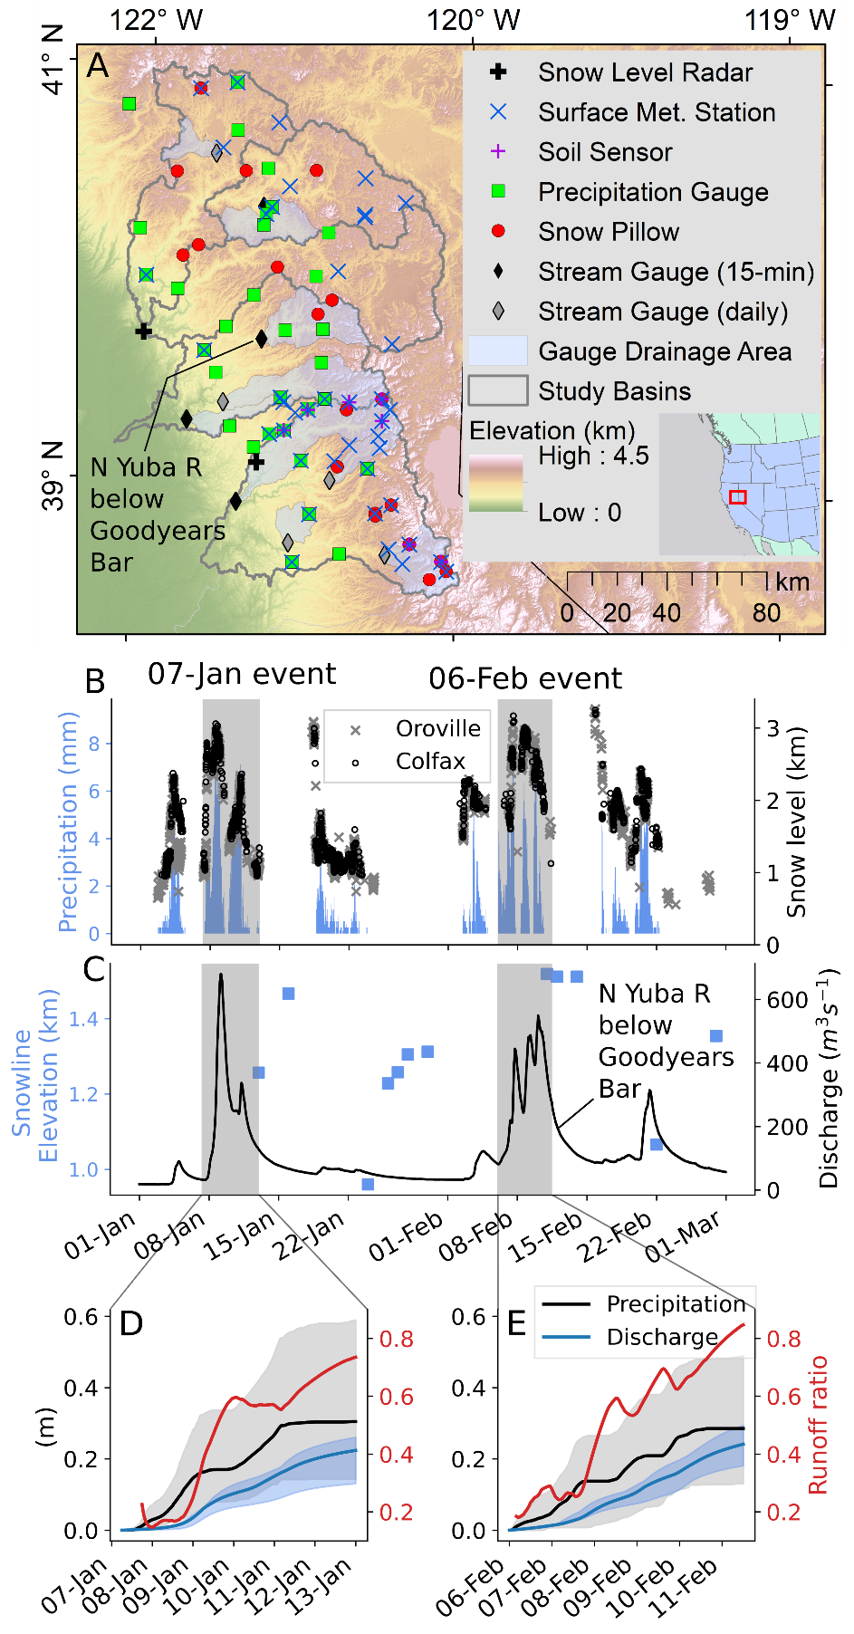
Figure 1. (A) Snow, river, and hydrometeorological monitoring stations in the Feather (North Fork, East Branch of North Fork, and Middle Fork), Yuba, and American River basins. Grey shaded areas drain to each USGS gage, which report daily or 15-minute measurements. (B) Median hourly incremental precipitation from the network in (A), and 10-minute brightband height from snow level radars in January through February 2017. The 7 January and 6 February storm sequences are grey shaded. (C) Daily regional snow line elevation (calculated using MODIS fractional snow-covered area), and 15-minute stream discharge at USGS gage 11413000. Cumulative discharge and precipitation median and range are shown for the (D) 7J and (E) 6F storm events, with median runoff ratios shown in red.

The 7J sequence accumulated 329 mm of precipitation (median across precipitation gauges in the three study basins), and 224 mm of coincident discharge (median across stream gauges; Fig. 1D). Snow levels (and discharge) rose rapidly beginning 7 Jan 0730Z, peaking at 3,059 m (above the highest point in all three basins) at 8 Jan 1350Z before falling. A warm pulse of precipitation brought snow levels up to 2,364 m (above 98% of the study area) on 11 Jan 0420Z before declining, accompanied by a secondary peak in streamflow. The event was followed by a relatively cold and modest storm from 13-23 Jan, with 103 mm of median precipitation and snow levels averaging 1,319 m (above 35% of the basin). This colder, smaller storm minimally impacted streamflow, but lowered the regional snowline to 960 m (Fig. 1C, 2B).
The 6F event began with a rapid rise in snow levels from 1,915 to 3,169 m between 7 Feb 0200Z-1400Z (Fig 1B), lowering gradually. Three waves of precipitation occurred in succession, each with snow levels above 1,500 m and distinctive streamflow signatures (Fig. 1B, 1C). The 6F event accumulated 322 mm of median precipitation and 241 mm of median discharge. The streamflow responses and concurrent soil moisture signatures (shown later in Fig 5C) for both the 7J and 6F sequences, taken together with snow levels above the regional snow line, provide evidence for ROS.
Both ROS events have similar synoptic characteristics (Fig. S1; Table S1). We assessed these during periods when snow levels exceeded 1,600 m. 7J and 6F total integrated vapor and heat transport, and average moist static energy gradients between 500- and 850-hPa, are within ±4% (Table S1). This suggests the atmospheric conditions in each ROS event sustained similar degrees of heat and moisture advection and static stability⁵⁹ over the study basins. Nonetheless, surface stations indicate the 6F event was generally warmer, particularly below 1,200 m, while the 7J event was more wind-driven (Table S1; corroborated by reanalysis-derived wind fields in Fig. S1). One notable difference was cold frontal passage during 7J with a ~1,250 m decline in snow levels (Fig. S1, 1B). Given a greater runoff-to-precipitation ratio (0.85) and a slower decline in snow levels in the 6F event (Fig. 1B, 1D, 1E), snowmelt may have augmented the 6F hydrograph, which preceded the spillway incident at Lake Oroville^{19,55}.

Snow as a Passive Conduit for Rainfall

A previous case study inferred the importance of snowmelt in the 6F event by noting that while precipitation only ranked the 9th-highest (on record) in the Feather River basin, runoff, in contrast, was ranked 2nd-highest¹⁹. The authors reasoned the extreme discharge was only possible with supplemental snowmelt. They estimated that snowmelt augmented TWI by approximately 37% relative to rainfall alone, which was supported by observations of daily snow water equivalent (SWE) decreases at snow pillows, an upslope migrating snow cover, and subsequent declines in spatially-distributed SWE between 24 January and 12 February¹⁹. While high runoff ratios (Fig. 1D, 1E) and above 0˚C temperatures (Table S1) indeed suggest snowmelt amplified TWI, we provide three lines of evidence suggesting a different interpretation of events.
First, while we do not contest that snowlines retreated during the study period, we do contest how much of the retreat can be attributed to ROS versus ablation unrelated to the 6F storm event. SWE estimates (blending station interpolation and modeled reconstruction) constrained by cloud-free satellite images of fractional snow-covered area (fSCA) on 24 January and 12 February–bracketing the event–were used by the previous study to calculate ROS snowmelt¹⁹. This is reasonable given cloud cover and/or large zenith angles⁶⁰ on days closer to the event. However, a visual inspection of all available images reveals a substantial snowline withdrawal before the 6F event occurred–from 960 m on 24 January to 1312 m on 30 January (Fig 2B-C). During this time, there were no changes in observed streamflow (Fig 2H) nor snow pillow SWE (Fig 4C) during this period. However, observed diurnal soil moisture increases within this elevation range accompanied warm, humid conditions until fSCA disappeared (Fig 2F-G). This, along with regional modeled estimates of snowmelt and soil moisture responses from the Variable Infiltration Capacity (VIC⁶¹) hydrologic model (Fig 2I) suggest this ephemeral snow withdrawal had a limited contribution⁶² to the 6F event’s antecedent conditions. The extensive fSCA on 24 January therefore may have led to a misinterpretation that the subsequent 6F event produced a larger snowmelt contribution to ROS flooding than had actually occurred. The size of this bias depends on the difference between watershed volumes of SWE on 24 January and 5 February.
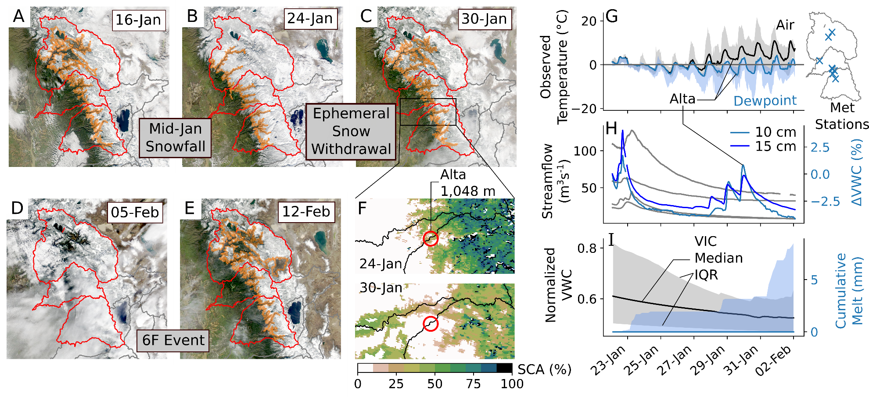
Figure 2. True-color evolution of the snow cover spans snowfall (A-B) and its disappearance in late January (C) preceding the February 2017 ROS event (D-E). Orange contours show the regional snow line elevation as in Fig 1C. The Alta station monitors both weather and soil, and is located in this ephemeral snow region transitioning from snow-covered to snow-free (F). Air and dewpoint temperatures at surface stations in this ephemeral elevation range (960-1312 m) gradually approach and exceed 0 ⁰C (G), with corresponding fluctuations in Alta’s soil moisture despite no responses in sub-daily streamflow (H). These indicate that the ephemeral snow melted (as opposed to sublimated), a result corroborated by distributed model estimates of minimal snowmelt and soil moisture response (I).

Second, using a distributed energy balance over the study area we estimate that snowmelt contributions to TWI were lower than previously calculated (relative to 76 mm, or ~25% of TWI¹⁹). To approximate the role of snowmelt in driving TWI and to conceptualize preferential flow in a completely “passive” ROS response to the 6F event, we conducted a “no-snow” experiment that considers only the 6F liquid precipitation. By removing the snowpack and snowfall after 5 February, the snowmelt volume and contributions to TWI are estimated counterfactually by its difference from a baseline estimation of the event (Fig 3A). In the Feather River basin, this difference in TWI (and thus approximate snowmelt volume) is 47 mm and is insensitive to the model’s precipitation partitioning temperature (Fig S2). This suggests a 38% less “active” snowpack than previously reported (augmenting TWI by 21% compared to 37%¹⁹). Importantly, rainfall comprises most of the TWI from both the 7J and 6F events–99 and 79% of the snow-covered areas have rainfall contributions to TWI exceeding 75%, respectively (Fig 3B-C). The regions in which the scenario difference in event-accumulated TWI is non-negative (Fig 3A) may be interpreted as “passive” or allowing preferential flow, as they indicate no additional snowpack contributions to TWI.

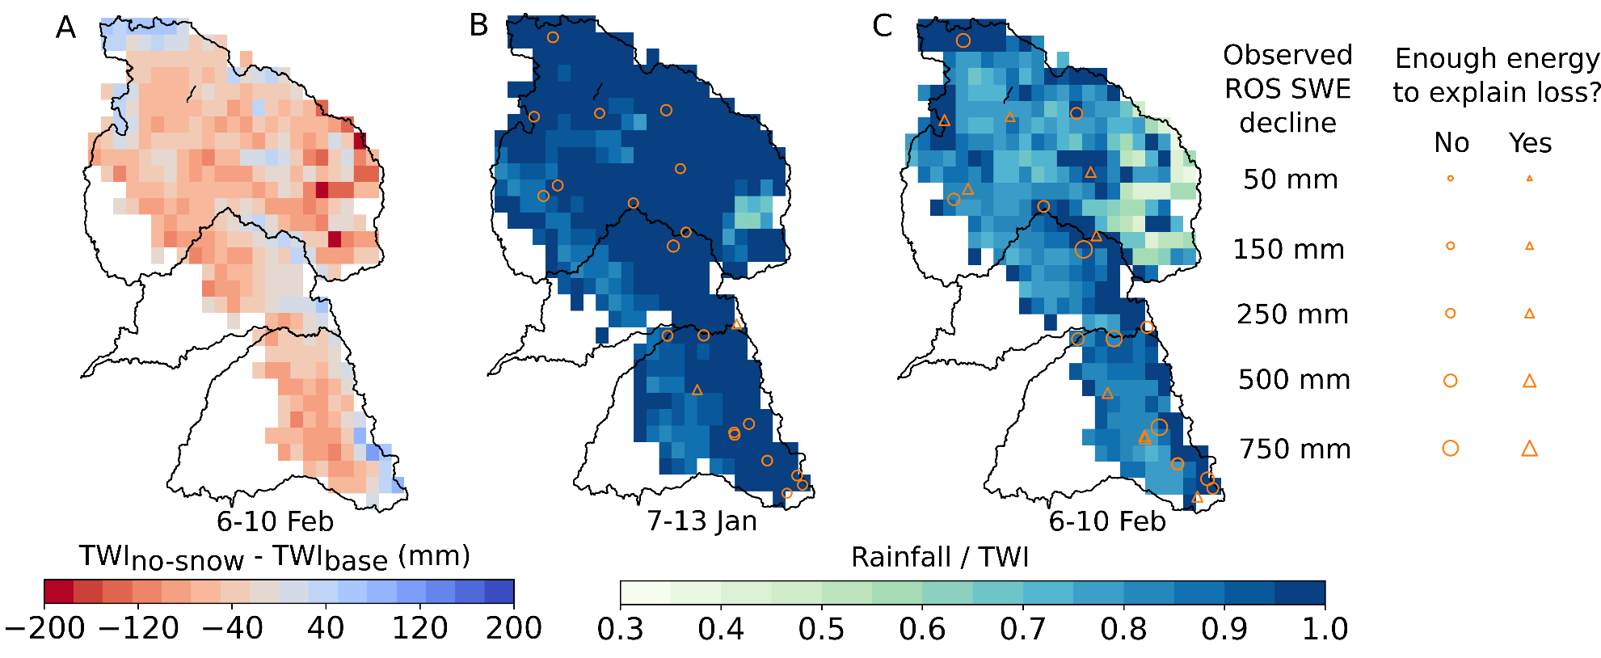
Figure 3. (A) The difference in accumulated TWI from the 6 February ROS event between a baseline simulation (“base”) and one in which all snow was removed on 5 February (“no-snow”) represents the role of snowpack in augmenting TWI. Baseline rainfall to TWI ratios in the (B) 7 January and (C) 6 February events show a dominant rainfall contribution to TWI. Marker indicate whether observed losses in SWE at snow pillows (Fig 4A-B, Fig S3-S5) could be completely explained as snowmelt via approximated net energy balance inputs integrated over each event’s period(s) of decreasing SWE.

Third, are “standard” daily measurements (including temperature, snow depth, SWE, and precipitation), which have been used previously to identify and interpret ROS events^{11,25,63,64}. While this avoids the instrument error- and noise-related problems with sub-daily measurements⁶⁵, daily timesteps may mask or misrepresent the mechanism(s) generating runoff during ROS. For instance, the 6F event showed widespread declines in daily SWE from 7 February (Fig. 3 in ¹⁹) through 10 February which could indicate widespread snowmelt. However, these daily measurements only correspond to roughly 1200Z as “daily” values are informed by only a single value between 0300-0400 local time rather than a median or mean across an entire 24-hour period (https://www.cnrfc.noaa.gov/awipsProducts/RNOFSTSWE.php; California Department of Water Resources, personal communication). In contrast, hourly SWE data paints a distinctly different picture, exhibiting SWE “pulses”⁶⁶ (Fig 4B, Fig S3-S5B). Importantly, the SWE rises and falls steeply—in some cases returning close to the same SWE as when the pulse began. These “pulses” also commence during times of heavy precipitation (6 February 0200Z) and snow density increases (a classic ROS indicator; Fig 4B, Fig S3-S5B), and occur when snow levels were above snow pillow elevations while air/wet-bulb temperatures were above 0°C. These observations converge on the likely presence of ROS. Given the steep slope of the “pulses” (both positive and negative), rather than assuming that this might be accumulating and ablating ice it could be hypothesized that this is in fact a mass shift due to the exchange of liquid water (i.e., rainfall saturation and then drainage). Pulses also occur across the snow pillow network⁶⁶ and earlier in the water year. A similar SWE pulse occurred during the 7J event (Fig 4A, Fig S3-S5A), and similar pulses have been observed across the Sierra Nevada during warm storms⁶⁷ and during past ROS events¹⁷. Moreover, some of these SWE oscillations occur in-phase with shallow (10 cm or less) collocated soil moisture measurements (Fig 4D), supporting the notion that “pulses” resemble transient rainfall storage and passage through snow. Importantly, the falling limb of these pulses may not necessary be entirely snowmelt. Our energy balance modeling supports this notion with not enough energy available to melt the observed SWE declines at half of the snow pillows (Fig 3C). In summary, our findings support the notion that daily snow pillow observations of ROS may be misleading, and may result in a larger perceived melt contribution to TWI.
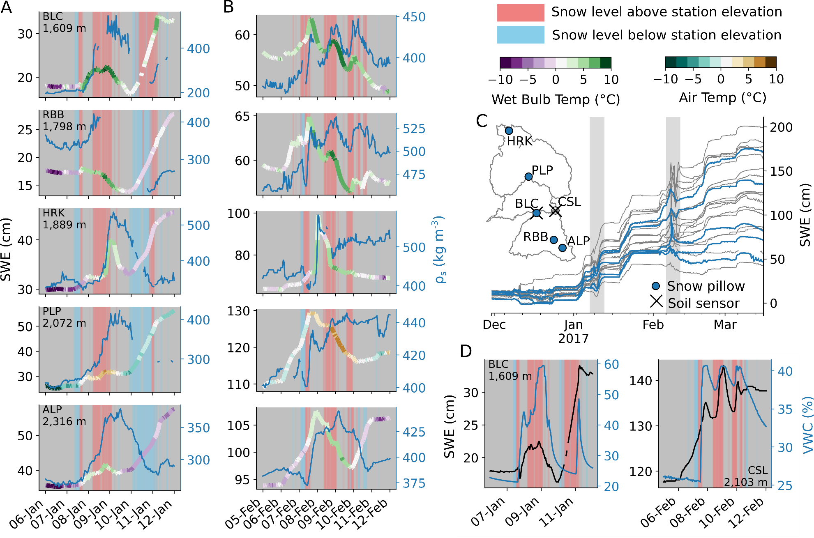
Figure 4. Snow pillow responses to the (A) 7 January and (B) 6 February ROS events show hourly SWE traces colored by air temperature (or wet-bulb temperature, if humidity measurements are available), and bulk snow density (if snow depth measurements are available). Vertical shading indicates periods when atmospheric snow levels were above or below snow pillow elevations. (C) Snow pillows and storms in A and B are plotted with respect to the winter 2017 at all snow pillows used in this study. (D) Two locations within our study basins have collocated SWE and soil moisture (≤ 10 cm depth) during these storm events, showing in-phase responses to rainfall.

We note, however, that this interpretation does not prove that the ROS responses at snow pillow stations were completely passive. It is possible, for instance, for out-of-phase soil moisture-SWE behaviors during ROS to occur as a result of lower-conductivity soils (Fig S6). This may be indistinguishable from the SWE-soil moisture trace during snowmelt⁶⁸, making it inappropriate to infer active/passive responses from these measurements alone. A lack of observations (e.g., stable isotopes to separate rainfall from snowmelt) leaves this “passive” interpretation open and testable, but out of this study’s scope.
It is also possible that rainfall underestimation makes up for inflated snowmelt contributions to TWI. Quantifying mountain precipitation is a pervasive hydrometeorological challenge⁶⁹ tied directly to estimating relative snowmelt contributions to TWI. Applying a simple wind-correction factor⁷⁰ from hourly reanalyses to gridded precipitation raises 7J and 6F precipitation by 6-12% (Fig. S7). However, this assumes precision in the precipitation field and accuracy in the wind field, which tends to be muted in mountains⁷¹. This, and unaccounted orographic enhancement of precipitation⁵⁵, appear to make this correction a lower bound (thereby lowering the melt contribution to TWI). However, ground and satellite observations are partial to exposed, flat terrain. Vegetation tends to collect less snowpack in-stand compared to exposed areas⁷², yet it can shelter snow from wind-driven turbulent heat exchange, potentially lowering TWI during ROS^{12,17,73}. Beneath-canopy SWE and its in-storm changes are invisible to both satellite fSCA retrievals and snow pillows. Snow-covered areas in our study basins are dominated by forest (65-88%) compared to the meadow settings in which ground observations are collected (11-30%, Fig S8). This may affect: (1) the location of the regional snowline (as calculated using fSCA here) and (2) the TWI during ROS inferred from snow pillows⁷⁴. Relatively broader forest cover therefore suggests actual snowpack losses across watersheds may be lower (reducing the snowpack contribution to TWI) than what may be implied by in situ SWE losses. This is supported by our modeling results that account for canopy-snow interactions, indicating lower snowmelt contributions to TWI in the 6F ROS event.

Soils Connect and Amplify Consecutive Storms

If snowmelt did not drive the extreme ROS runoff, what other process(es) may explain the runoff? During WY 2017, successive winter precipitation events caused streamflow across the study basins to recess less with the onset of each storm event (Fig. 5A). This indicates an increasingly saturated landscape up until the 6F storm cycle, when log-transformed streamflow levels off. Soil moisture, even in snow-covered areas, echoed the streamflow trajectory. Soils returned to greater moisture levels after each TWI instance as winter progressed (Fig 5B-C), reflecting greater tendencies to generate runoff from TWI. The increases in “rest” levels of both soil moisture and streamflow suggest that these inputs increase runoff efficiency and baseflow⁷⁵. These antecedent conditions are corroborated by steady increases in groundwater levels, as observed from wells in the Yuba and Feather River basins (cf. Fig. 22 and 23 in ⁷⁶). Therefore we might conclude that the degree of discharge achieved during the 6F storm sequence was facilitated by the 7J sequence, and in turn, due to earlier runoff-generating storm events starting as early as mid-October⁵⁶.
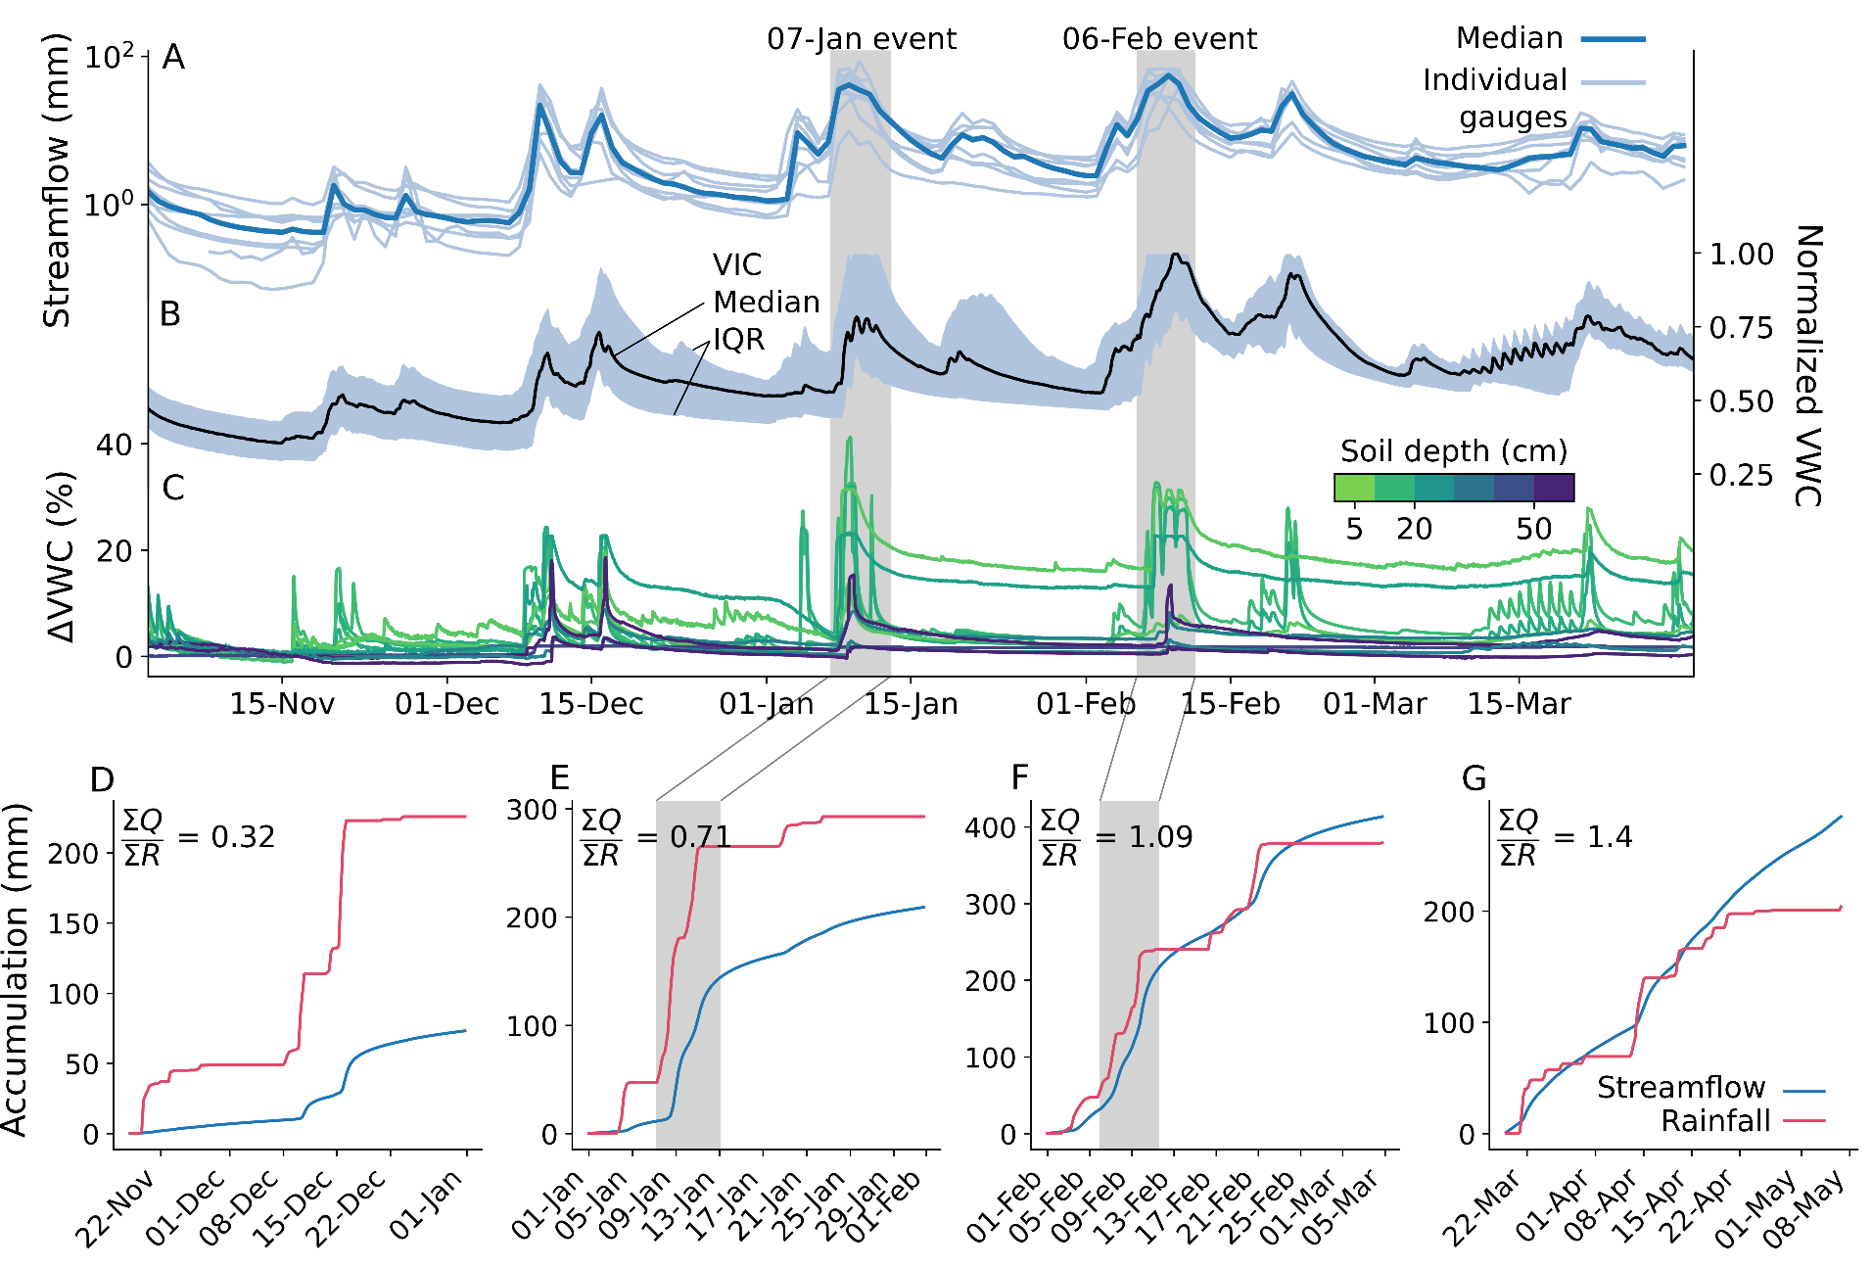
Figure 5. Winter (A) observed daily streamflow at nine gages and (B) modeled soil moisture in our study basins. (C) Departure in observed soil moisture at high-elevation stations (n=6 above 1,600 m) from values preceding the 16 November 2016 storm. (D) Streamflow and estimated rainfall (the liquid proportion of total precipitation) accumulations at the stream gauge in the central Feather (USGS gauge 11402000). Rainfall values are aggregated from gridded precipitation over the catchment area upstream of the gauge (Fig 1A). Note that the deep soil moisture at certain stations (e.g., at CSL) became saturated before this period and therefore display no change.

Over WY2017, runoff efficiencies increased; but what components (rainfall, snowmelt, and or/soil saturation) contributed to this increase? To answer this, we designed two thought experiments. First, we compared observed accumulated discharge and rainfall, and theorized that large snowmelt contributions should lead to runoff values that exceeded rainfall. Early-season (November-December 2016) rainfall registered relatively small amounts of discharge at the central Feather stream gauge (Fig 5D). Differences between cumulative discharge and rainfall narrowed after the 7J event (Fig 5E) and narrowed further still after the 6F event (Fig 5F). But, by the end of February, runoff exceeded rainfall by 9%--an indication that snowmelt may have driven some of the runoff increases. The rainfall exceedance is consistent with observed low-elevation SWE losses for which sufficient energy was available for melt (Fig 3C). We also examined a “null case” during the spring to test our thought experiment. As expected, spring discharge amounts strongly exceeded rainfall totals (Fig 5G) in association with widespread seasonal snowmelt that occurred by late March (Fig S9). Importantly, the near-linear spring discharge accumulation is distinct from the relatively abrupt accumulations following winter rainfall (Fig 5D-F). Stream gages in the Yuba and American River basins exhibited similar results to that in the Feather (Fig S10), although South Yuba runoff decreased in the spring as a result of minimal snow cover (Fig S11). It is worth noting that melt contributions may not be the only factor in augmenting streamflow; groundwater infiltration or exfiltration can conceivably dampen or amplify streamflow, respectively⁷⁵. Additionally, we partition rainfall here using upwind snow level radars in the Sierra Nevada foothills (Fig 1A). While dynamical and thermodynamical processes cause snow levels to bend downwards with increasing elevation along the windward slopes⁷⁷ (biasing the local liquid precipitation fraction⁶⁵), systematic lowering of the snow levels (Fig. S12) minimally affected our results and interpretation.
For our second thought experiment, we considered the effects of drier soils on modeled 6F event runoff. As expected (Fig 3A), the no-snow scenario produced less runoff from the snow-covered catchments (Fig 6A, C-D), indicating non-negligible snowpack contributions that are greatest, for example, at the central Feather River stream gage (Fig 6A). However, the baseline snowpack response over drier soils had a much greater runoff impact than the no-snow scenario. At the central Feather River stream gage, a 10% reduction in the 5 February soil moisture state produced a runoff response within 24% of the no-snow response (Fig 6A), while drying soils by 25% or more reduced runoff beyond what could be made up by the 6F snowmelt volume. All gages reflect this response (Fig 6). The dramatic difference between scenarios suggests that antecedent soil conditions are critical in forecasting ROS responses at the basin scale. Across the Feather River basin (Fig 6E), 10% drier soils produce comparable runoff relative to removing the snowpack. In other words, a 10% soil moisture bias has the same impact as a 100% snowmelt bias in this case. This difference (33 mm) corresponds to about 0.34 km³, or 8% of Lake Oroville’s 4.36 km³ storage capacity. This consequence is doubled with 25% drier soils. We note that the underestimates in event precipitation may explain the lower modeled streamflow in the Feather, as these biases share a similar magnitude (Fig S13). In the Yuba and American, however, low-biased flows begin after most of the event precipitation with minimal modeled soil inputs, suggesting a model deficiency in baseflow.

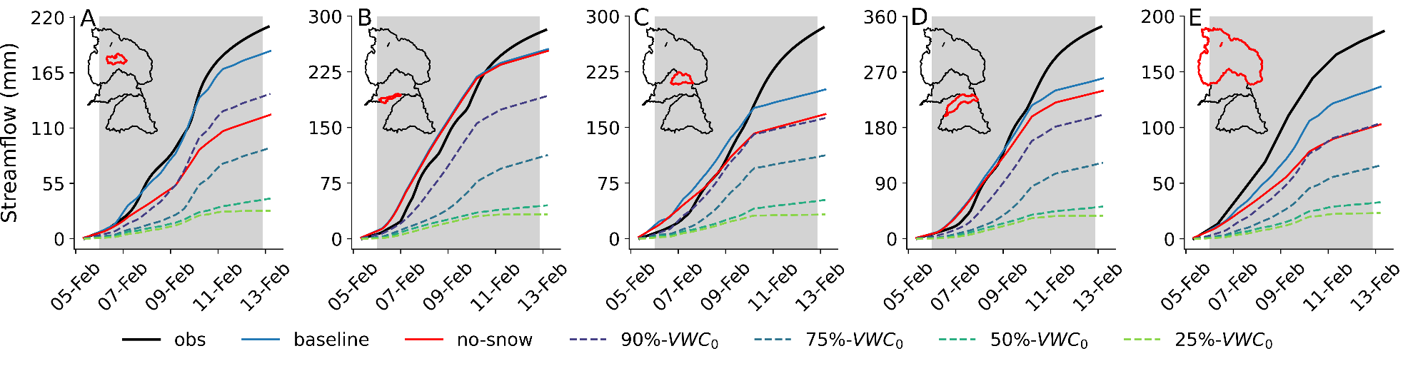
Figure 6. Observed and modeled cumulative streamflow during the 6 February ROS event at stream gages in the (A) central Feather, (B) south Yuba (USGS ID 11418500), (C) north Yuba, (D) North Fork American (USGS ID 11427000), and (E) the Feather River basin (observing full-natural flow into Lake Oroville). Scenarios compare the baseline run to experiments removing the 5 February snowpack (“no-snow”) and those systematically lowering the 5-February soil moisture (“N%-VWC₀”). Drainage areas are outlined in red.

These results indicate basin-scale ROS flood response (as with other flood mechanisms^{3,78–80}) is largely driven by saturated soils. We have shown this through two thought experiments demonstrating how increasingly efficient winter runoff volumes could be driven by saturated soils, and a somewhat “passive” snowpack that enables direct rainfall passage and contribution to runoff volumes—despite several large, warm ARs. Other cases of large, high-efficiency streamflow have been observed in other small, snow-dominated basins in the Western United States–caused by wet soils and winter rainfall occurring during periods of low potential evapotranspiration^{81–83}. However, disentangling snowmelt and groundwater (i.e., baseflow) contributions from rainfall inputs in driving streamflow generation⁸¹, and closing the water balance around these terms remains challenging in snow-dominated headwaters⁸⁴. While baseflow may be linked to snowmelt in sandy catchments favoring infiltration^{85,86}, parsing between them at the event scale requires fully-coupled atmosphere-through-bedrock observation and modeling frameworks^{87,88}. Nonetheless, we present evidence that the streamflow associated with ROS can be linked closely to the basin soil state as well as to the role of snowmelt, which we argue was smaller than prior research indicated. This link is crucial because it compels us to acknowledge that the record-setting “Oroville event,” hydrologically, was born from a chain of consecutive events that cumulatively primed the system⁸⁹ to respond to a single, high-impact event. Indeed, had a more widespread, “active” snowmelt response transpired during the 6F storm sequence, the risk of dam failure and catastrophic flooding would have arguably been much greater.

Conclusions, Challenges, and Recommendations

Winter 2017 in California’s Sierra Nevada brought numerous landfalling warm ARs and multiple widespread flooding events. Two major storm sequences – beginning on 7 January and 6 February – had high snow levels and yielded extreme streamflow volumes in the Feather, Yuba, and American River basins (Fig 1). Both storms shared several synoptic characteristics (Table S1), with the February event yielding less rainfall but more runoff than the January event. To explain this difference, we present evidence that snowmelt was not the primary flood driver, at least to the extent previously suspected. We show that (1) much of the snow cover on 24 January (underlying previous melt contribution estimates¹⁹) vanished prior to the event itself (Fig. 2), and (2) that hourly snow pillow responses to ROS revealed a potential to misinterpret SWE loss for snowmelt, as the energy to explain such losses was not always available (Fig 3). Rather, a “passive” response to ROS may involve snow liquid water content rising to saturation and then draining, producing measured SWE gains and losses. A series of idealized model experiments supported this interpretation suggesting that snowmelt during ROS was a relatively small part of a broader cause of the extreme runoff in the February event. The cascade of prior storm inputs gradually raised antecedent soil moisture and, in turn, led to increasingly efficient runoff (Fig 5). Importantly, we show that event-scale ROS runoff generation is dramatically more sensitive to pre-event soil moisture than to event snowmelt (Fig 6). This characteristic links successive storm events together and enhances responsiveness to a single, high-impact storm.
Nonetheless, the presence and danger of “active” snowmelt during mid-winter ROS as a potential flood driver should not be dismissed. This is not our intention. Rather, we encourage developing our current understanding of whether a snowpack will be “active” or “passive”, and how landscape saturation levels modify the associated flood risk during ROS. This large-scale understanding must avoid fixating on a single component in explaining entire events. Socially, we tend to remember past extreme events–our perceptions of which affect how we prepare for and respond to future events⁹⁰. Thus, an accurate, transferrable understanding and representation of the physical mechanisms of ROS will enable past events to better guide management responses in the future. The Oroville incident itself was punctuated by spillway failures that exacerbated a catastrophic flood threat⁵³ despite the ROS component falling within a global, climatological range of snowmelt contributions to TWI¹². It stands alongside several historic flood events—across the Sierra Nevada⁴, North America^{17,21}, and worldwide¹⁸—that places a memorable spotlight on the challenges ROS presents to large, vulnerable systems. The fact that we can produce an alternative explanation for the hydrology of the Oroville incident is concerning, as it exposes epistemic uncertainty through our perception of a past event. In preparing for a more uncertain future, this “gap” demands elevated observational and modeling capacities to identify the correct physical processes and their coupling to interpret such events. We therefore recommend future efforts focused on the following:
(1) Precipitation phase and intensity. This is a foundational yet elusive forcing in mountain environments, and a first-order control on deciphering the relative importance of precipitation versus snowmelt during ROS. Despite improvements in humidity-aware proxies⁵¹ and the utility in vertically-oriented radars, the optimal approach in estimating precipitation phase is direct observation^{91,92}. This may be partial to daylight hours and ambiguous during mixed-phase precipitation. However, combining such citizen science with denser, robust observation networks will bolster on-the-ground representation, and may help to better constrain weather model physics⁶⁹ and satellite retrievals of mountain precipitation.
(2) Snowpack structure and energy balance. This largely dictates the volume and timing of the flood response to ROS. Snow pit observations provide snowpack stratigraphy, cold content and liquid water content, helping to identify likely flow regimes and melt response to meteorological inputs. However, bracketing snow pit observations around ROS events requires intensive field campaigns. Dye tracer experiments carry similar benefits, but the post hoc nature of these approaches is impractical for hazard and water supply monitoring. We recommend cost-effective automated or semiautomated efforts to map^{93,94} and to continuously and noninvasively monitor^{95,96} these quantities across watersheds⁹⁷ and land cover types. Process-scale monitoring of basic snow properties–which must be coupled with accurate surface and boundary layer characteristics–can be exploited for more representative modeling frameworks. Such measurements can improve process-aware constraints on the simplifying parameterizations that accompany models. They may also support developing more effective discretization schemes that respect the physical differences between matrix and preferential flow^{33,98}. This is an important feature for next-generation models to conceptualize, given how dramatic these differences can be^{27,45}.
(3) Graduation to scale. How the above-mentioned processes translate from the point and hillslope to basin scale is crucial to guide management decisions. Some of our analyses rely on observations located in flat clearings (and satellite estimates of SCA, which are partial to clearings and sparse vegetation). The snow pillow network occupies elevations as low as ~1,600 m in the Sierra Nevada, roughly 300 m higher than the pre-6F event snow line (Fig 1B, 2C). Lower-elevation ephemeral snow cover, while unmonitored, is likely a more “active” contributor to snowmelt during ROS. While thinner, the areal extent and low cold content of such snowpacks become important in favorable storm sequences (e.g., warm, intense precipitation immediately following snowfall). In-storm shifts in this boundary and its SWE affect the tributary area and volume of ROS response^{4,99} and therefore should be tracked to understand its relationship to basin flood response. Moreover, being able to monitor exchanges between ground and surface water stores would help to evaluate the interrelationship between ROS, ephemeral snow cover, and runoff response as an integrated system. This may benefit from synthesized critical zone observations^{85,100} and isotopic analyses¹⁴ across landscapes.
Facing a climate more prone to high-impact ROS^{1,11}, even as ROS events themselves become less frequent with snowpack declines^{1,11,101}, transdisciplinary efforts aimed toward understanding hydrologic connectivity across scales are paramount to overcoming these barriers. In addition to better understanding the governing processes of snowpack flow routing and snowmelt, we emphasize it is also worth looking up, down, and backward – “up” to understand in-storm changes to precipitation phase and boundary layer dynamics; “down” to understand the subsurface role in surface-groundwater exchange and basin-scale runoff generation; and “backward” to consider how soil and snow’s “memory” of preceding hydrometeorological events may affect subsequent ones. Moreover, we suggest investments prioritizing soil moisture monitoring, prediction and data assimilation. The natural mitigation of runoff from modestly drier soils¹⁰²–even from high-impact ROS–implies an important constraint on the efficacy of floodwater-derived adaptive measures to counter long-term drought such as managed aquifer recharge and forecast-informed reservoir operations. Such efforts will strengthen the operational tools¹⁰³ for managing water availability and hazards posed by ROS in a society dependent on increasingly warmer and variable winter season precipitation.

Materials and Methods

In situ snow, soil, and meteorological measurements

Point measurements for snow water equivalent (SWE), snow depth, soil moisture, air temperature, wind speed, relatively humidity, and precipitation were obtained at an hourly timescale (or sub-hourly, if available) from multiple networks in the Northern Sierra Nevada. All data were converted to UTC and metric units.

Snow Water Equivalent and Snow Depth

The California Department of Water Resources (DWR) manages a network of ~130 automated monitoring stations across the Sierra Nevada that measure SWE from snow pillows. In the northern Sierra Nevada, some of these stations are run by the Natural Resources Conservation Service (NRCS) as part of the SNOTEL network—but regardless all data are posted to the DWR California Data Exchange Center (CDEC, http://cdec.water.ca.gov/snow/current/snow/index.html). We obtained hourly SWE from 22 snow pillows in the Feather, Yuba, and American River basins from CDEC. SWE values were quality-controlled manually. Metadata for snow pillows used in this study are provided in Table S2.
Several stations include ultrasonic snow depth measurements from either DWR or the American River Hydrologic Observatory (ARHO¹⁰⁴) – a distributed sensor network with each station comprising a cluster of sensor nodes. We use the cluster median for 4 ARHO stations and 7 DWR stations (Table S2). Both SWE and snow depth measurements were quality-controlled manually (the procedure is described in the Supplement).

Soil Moisture

Soil volumetric water content (VWC) is measured at few NRCS and DWR stations in our study basins (n=1). To raise the number of samples, we obtained VWC measurements from networks independent from CDEC and NRCS. These include the Western Regional Climate Center (WRCC, https://wrcc.dri.edu/), the National Oceanic and Atmospheric Administration Physical Sciences Laboratory (NOAA PSL, https://psl.noaa.gov/data/obs/datadisplay/), and the ARHO. VWC values from NOAA PSL were converted from raw reflectometry measurements using the standard coefficients in the corresponding data logger manual (Table 4 in https://psl.noaa.gov/data/obs/instruments/SoilWaterContent.pdf). VWC values from ARHO are the cluster median at each station. Our expanded sample (n=7) occupies an elevation range from ~1,050 to ~2,700 m, and is described in Table S3. The depth and timestep of data vary by station and network. We aggregated sub-hourly measurements to hourly timesteps after quality control via screening measurements when soil temperatures dropped below 0 ⁰C.
VWC served three purposes in this study. First, the lowest-elevation sensor was used to infer ephemeral snowmelt between the 7J and 6F events. Second, we used the shallowest available sensors with collocated SWE to infer “passive” snowpack behavior as SWE increasing simultaneously with VWC during rainfall. The shallowest nodes (5-10 cm) were used to represent the snow-soil interface, and minimize the effect of differences in hydraulic conductivity across different soils. Second, we use the elevation gradient in soil moisture to show a widespread increase in antecedent conditions resulting from winter storm events.

Surface Meteorology

Measurements of precipitation, air temperature, relative humidity, and wind speed were obtained from CDEC, WRCC, and MesoWest. Similar to our VWC collection, we obtained data from WRCC and MesoWest for stations/variables that were absent from CDEC. The MesoWest portal (https://mesowest.utah.edu/), provided data from the National Weather Service and other Remove Automatic Weather Stations. We screened available measurements for each variable and applied quality control prior to analysis (described in detail in the Supplementary Text). We used a total of 31 precipitation gauges to bound the range of precipitation during each storm over the study basins (Table S4). We used a total of 41 stations reporting temperature, humidity, and wind speed, though not all measurements were suitable for both storms of interest (Table S4; Supplementary Text). Temperatures and winds were summarized for each storm at 4 elevation bands (Table S1).

Streamflow

Stream discharge measurements were obtained from the U.S. Geological Survey (USGS) National Water Information System (https://waterdata.usgs.gov/nwis). We used a total of 9 gages in this study (Table S5), but only four report measurements at a 15-minute timescale. These higher-frequency measurements were used in analyses with other sub-daily data. Daily measurements were used to illustrate how streamflow evolved over the winter season. We selected gauges from the Geospatial Attributes for Gages for Evaluating Streamflow (GAGES-II) data set¹⁰⁵ that reflected unimpaired streamflow – either by its GAGES-II classification as “Reference,” or by screening stations below reservoirs or diversions. Observations were visually inspected to screen out gauges reflecting upstream regulation (e.g., as “stepwise” changes unassociated with precipitation or snowmelt) or otherwise missing/erroneous measurements.

Snow Level Radars

Several Frequency Modulated-Continuous Wave snow level radars managed by NOAA PSL occupy the Central Valley and foothills of the Sierra Nevada. The brightband height (BBH) from these upward-looking S-band (2.8 to 3.0 GHz) radars estimate the melting level aloft, derived from an algorithm that inspects range gates for the maximum reflectivity and increasing Doppler fall velocity associated with melting snowfall¹⁰⁶. The algorithm involves a self-consistency test with neighboring 30-second measurements as a quality control measure for the aggregated 10-minute measurements. We used 10-minute BBH measurements from the Oroville and Colfax radars in this study (Table S6) as a measure of the likely phase of precipitation. We note that because these sensors are located in the Central Valley, they may not always truly reflect mountain based melting levels⁷⁷.

Remote Sensing

True-color images from NASA Worldview (https://worldview.earthdata.nasa.gov/) were used for qualitative assessment of cloud and snow coverage. We obtained estimates of snow-covered area (SCA) from the Moderate Resolution Imaging Spectroradiometer (MODIS) Snow-Covered Area and Grain Size (MODSCAG) algorithm¹⁰⁷, which retrieves these properties daily at 500 m. Scenes over the study basins were used for near-cloudless (below 20%) days that had no apparent cloud coverage in Worldview. We then used SCA to calculate the regional snow line elevation over the aggregated study basins¹⁰⁸.

Atmospheric Reanalysis

The 5th generation of atmospheric reanalysis from the European Centre for Medium-Range Weather Forecasts (ERA5) provides hourly atmospheric variables on a 0.25˚ grid¹⁰⁹. We obtained ERA5 geopotential, air temperature, specific humidity, and zonal and meridional winds at 27 pressure levels (from 1,000 to 100 hPa) from the Copernicus Climate Change Service’s Climate Data Store (https://cds.climate.copernicus.eu/). We also obtained hourly 0.1˚ surface wind and 0˚C altitude variables from ERA5-Land¹¹⁰.

Synoptic Analysis

To assess synoptic differences between the January and February storm events over the study basins, we calculated the moist static energy (MSE) at each pressure level and the integrated vapor and heat transports (IVT, IHT). Equations are presented in the Supplementary Text. In essence, IVT and IHT are wind-weighted quantities of moisture and heat, respectively, which are the key ingredients to turbulent fluxes (latent and sensible heat fluxes, respectively) at the surface, depending on the moisture and heat contents of the snowpack surface. We took the difference in MSE between 500 and 850 hPa as a relative measure of static instability⁵⁹, where smaller gradients indicate less static stability and thereby a greater uplift tendency and conductance for turbulent fluxes. Taken together, these metrics lend some insight to the relative strength of atmospheric river-related melt drivers¹⁷ between the January and February events. We also report supporting air temperature and wind speed comparisons from available surface stations (Table S4; see sub-section “Surface Meteorology” above).
We report the surface air temperature, wind speed, IVT, IHT, and MSE gradient from each storm during hours when BBH (at either Oroville or Colfax) exceeded 1,600 m. These high-BBH hours were isolated in an effort to capture the prevailing conditions during rainfall over the study basins. The 1,600 m threshold was selected to nominally represent the lower regions of the snow pillow network (Table S2) to suggest that rainfall is likely occurring over low-lying snow cover, at the very least. Given that this value resided on average a few hundred meters above the regional snow line elevation, this threshold inherently accounts for the regional lowering of upwind melting levels⁷⁷ that can positively bias BBH values applied downwind for precipitation phase partitioning. Both IVT and IHT were expressed as accumulations (kg m⁻¹ and J m⁻¹) over the high-BBH timesteps. Values for the MSE gradients were averaged over high-BBH timesteps.

Cumulative discharge and rainfall comparisons

To assess both runoff efficiency and the notion of snowmelt augmenting TWI above rainfall alone, we compared rainfall estimates to observed discharge at each subdaily USGS gage over 4 intervals in the snow season. We hypothesized that runoff efficiency would grow over the course of the winter as liquid inputs accumulated to raise antecedent soil moisture, and that the presence of snowmelt and rainfall together would bring discharge above rainfall totals.
We partitioned gridded (4-km), 6-hourly precipitation from the California Nevada River Forecast Center (CNRFC, https://www.cnrfc.noaa.gov/arc_search.php) over the drainage areas of each subdaily USGS gage using BBHs from the nearest snow level radar. We first aggregated the 10-minute BBHs to hourly values. We filled the remaining gaps in the hourly time series using ordinary least squares regression of hourly BBH against the 0˚C altitude from the nearest ERA5-Land pixel from November 2016 through early May 2017. Regression results at the Oroville (n=664) and Colfax radar (n=671) yielded R² values of 0.93 and 0.95, respectively, with a standard error of 0.01 m. This gap-filled time series was then aggregated to 6-hourly values to match CNRFC, then lowered by 200, 400, and 600 m to test different degrees of snow level bending⁷⁷. Using this to partition rainfall from CNRFC precipitation, we compared these accumulated rainfall estimates and accumulated observed discharge separately for the following periods: (1) the early winter season, from 15 November (the first large rainfall event) through December (2) January, encompassing the first AR of interest, (3) February, encompassing the second AR, and (4) early spring, from 16 March (the first rainfall event) through early May. These time frames were chosen such that rainfall began early in the period and ceased before the end of the period, but allowing several days of concentration time before the next rainfall event.

Variable Infiltration Capacity model experiments

We used the spatially distributed Variable Infiltration Capacity (VIC, version 4.2d) hydrologic model⁶¹ to experiment and estimate the energy balance during ROS. The VIC snow model³⁶ simulates mass and energy transfers between the atmosphere, overlying vegetation, and underlying snowpack, including drip, interception, and sublimation processes. The snow model has been validated in the Sierra Nevada and utilized previously to investigate ROS flooding across the United States^{1,3}. We ran VIC here in energy balance mode, with grid cells subdivided into five elevation bands and further into up to 12 vegetation tiles. Energy and mass states and fluxes are computed for each grid cell subdivision and output as the area-weighted average. Daily, 1/16⁰ (~6-km) forcings of total precipitation, wind speed, and minimum and maximum air temperature were obtained from an extended version of the Livneh et al¹¹¹ product (L15), which adjusts its temperature and precipitation fields for orographic effects using the Parameter-elevation Regressions on Independent Slopes Model¹¹² climatology. The mountain microclimate simulation model¹¹³ derives the remaining forcings used by VIC – downwelling short- and longwave radiation, and vapor and atmospheric pressure. It permits subdaily simulation by disaggregating the daily forcings to reflect diurnal variation. Precipitation was partitioned into liquid, solid, and mixed phases by an air temperature range in which precipitation falling below -0.5 ⁰C and above +0.5 ⁰C were classified as snowfall and rainfall, respectively, with mixed rain and snow calculated by interpolation for temperatures within this range. We also explored a temperature range of 0.0 to +2.0 ⁰C, which does not affect results. We used the L15 land surface parameters, which were calibrated for major river basins¹¹¹ and applied successfully in several studies^{1,3,86,101} across the United States. We ran this configuration at an hourly timescale over the study basins beginning 1 October 2015 to allow one year of spin-up time. However, we use 3-hourly output to compromise needs for subdaily variation while avoiding artifacts in the disaggregation of daily forcing data
VIC simulations served three purposes in this study. First, we approximated net energy inputs at grid cells nearest to snow pillows to determine whether the observed SWE decreases in “pulses” during ROS could be explained as snowmelt. To better-represent the exposure at snow pillows, turbulent heat fluxes were calculated as in Andreadis et al.³⁶, using modeled snow depth and a snow surface roughness length of 1 mm¹⁶ to estimate aerodynamic resistance. Net-positive (downward) fluxes of net radiation, turbulent fluxes, and rainfall heat advection when modeled snow surface temperatures were above -0.5 ⁰C were integrated over the durations of observed SWE decreases during the 7 January and 6 February ROS events. These net fluxes were converted to equivalent ice melt rates by dividing the energy values by values for water density and latent heat of fusion. These were compared to the sum of negative changes in snow pillow SWE. Instances where modeled melt had met or exceeded observed SWE losses were deemed to have sufficient energy inputs to completely explain losses as snowmelt, as opposed to “passive” routing of liquid through snow.
Second, we conducted a no-snow experiment to approximate the role of snowpack in augmenting the 6 February ROS event flood response. We set all snow variables in the model state (SWE, fSCA, liquid water content, snow density, cold content, and pack and surface temperatures) to zero (mm or ⁰C) on 5 February and reinitialized the model with liquid-only precipitation. The precipitation forcing was equivalent to the liquid proportion in the baseline simulation. Snow/rain discrimination temperatures were set to -273 ⁰C to ensure all precipitation fell as rain (rather than raising the forcing air temperature, which may affect evapotranspiration).
Lastly, we simulated the 6 February event with systematically drier soils to test our hypothesis of the event flood response being driven more by wet soils than by snowmelt. We reduced the soil moisture at each of the three soil layers in the 5 February state by scaling each layer by a given fraction (10, 25, 50, and 75%) before reinitializing the model with unperturbed snowpack and precipitation. In addition to the energy balance and snow pillow analysis, we report modeled inflows to the soil column (TWI), total runoff (the sum of surface runoff and baseflow), and soil moisture (normalized between grid cell VWC values for field capacity and wilting point).

Acknowledgments

The University of California Research Initiatives Award LFR-18-548316, NOAA Grant number NOAA-AOR-OWAQ-2019-2005820, and UCAR Grant subaward 001987 provided support for this research. We acknowledge the use of imagery from the NASA Worldview application (https://worldview.earthdata.nasa.gov), part of the NASA Earth Observing System Data and Information System (EOSDIS). We sincerely thank three anonymous reviewers for thoughtful feedback and suggestions which improved the clarity and contribution of this study.

References

1. Li D, Lettenmaier DP, Margulis SA, Andreadis KM. The Role of Rain-on-Snow in Flooding Over the Conterminous United States. Water Resources Research. 2019;55(11):8492–8513. doi:10.1029/2019WR024950
2. Welty J, Zeng X. Characteristics and causes of extreme snowmelt over the conterminous United States. Bulletin of the American Meteorological Society. 2021;102(8):E1526–E1542. doi:10.1175/BAMS-D-20-0182.1
3. Tarouilly E, Li D, Lettenmaier DP. Western U.S. Superfloods in the Recent Instrumental Record. Water Resources Research. 2021;57(9):e2020WR029287. doi:10.1029/2020WR029287
4. Kattelmann R. Flooding from rain-on-snow events in the Sierra Nevada. In: IAHS Publications-Series of Proceedings and Reports-Intern Assoc Hydrological Sciences. Vol. 239. 1997. p. 59–65.
5. Ingram LB. California megaflood: Lessons from a forgotten catastrophe. Scientific American. 2013;308. https://www.scientificamerican.com/article/atmospheric-rivers-california-megaflood-lessons-from-forgotten-catastrophe/
6. Guan B, Waliser DE, Ralph FM, Fetzer EJ, Neiman PJ. Hydrometeorological characteristics of rain-on-snow events associated with atmospheric rivers. Geophysical Research Letters. 2016;43(6):2964–2973. doi:10.1002/2016GL067978
7. Hatchett BJ, Daudert B, Garner CB, Oakley NS, Putnam AE, White AB. Winter snow level rise in the Northern Sierra Nevada from 2008 to 2017. Water. 2017;9(11):899. doi:10.3390/w9110899
8. Corringham TW, Martin Ralph F, Gershunov A, Cayan DR, Talbot CA. Atmospheric rivers drive flood damages in the western United States. Science Advances. 2019;5(12):eaax4631. doi:10.1126/sciadv.aax4631
9. Gershunov A, Shulgina T, Clemesha RES, Guirguis K, Pierce DW, Dettinger MD, Lavers DA, Cayan DR, Polade SD, Kalansky J, et al. Precipitation regime change in Western North America: The role of Atmospheric Rivers. Scientific Reports. 2019;9:9944. doi:10.1038/s41598-019-46169-w
10. Rhoades AM, Jones AD, Srivastava A, Huang H, O’Brien TA, Patricola CM, Ullrich PA, Wehner M, Zhou Y. The Shifting Scales of Western U.S. Landfalling Atmospheric Rivers Under Climate Change. Geophysical Research Letters. 2020;47(17):e2020GL089096. doi:10.1029/2020GL089096
11. Musselman KN, Lehner F, Ikeda K, Clark MP, Prein AF, Liu C, Barlage M, Rasmussen R. Projected increases and shifts in rain-on-snow flood risk over western North America. Nature Climate Change. 2018;8(9):808–812. doi:10.1038/s41558-018-0236-4
12. Brandt WT, Haleakala K, Hatchett BJ, Pan M. A Review of the Hydrologic Response Mechanisms During Mountain Rain-on-Snow. Frontiers in Earth Science. 2022;10:791760. doi:10.3389/feart.2022.791760
13. Juras R, Würzer S, Pavlásek J, Vitvar T, Jonas T. Rainwater propagation through snowpack during rain-on-snow sprinkling experiments under different snow conditions. Hydrology and Earth System Sciences. 2017;21(9):4973–4987. doi:10.5194/hess-21-4973-2017
14. Rücker A, Boss S, Kirchner JW, Von Freyberg J. Monitoring snowpack outflow volumes and their isotopic composition to better understand streamflow generation during rain-on-snow events. Hydrology and Earth System Sciences. 2019;23(7):2983–3005. doi:10.5194/hess-23-2983-2019
15. Garvelmann J, Pohl S, Weiler M. Spatio-temporal controls of snowmelt and runoff generation during rain-on-snow events in a mid-latitude mountain catchment. Hydrological Processes. 2015;29(17):3649–3664. doi:10.1002/hyp.10460
16. DeWalle DR, Rango A. Principles of Snow Hydrology. 1st ed. New York: Cambridge University Press, New York; 2008. doi:10.1017/CBO9780511535673
17. Marks D, Kimball J, Tingey D, Link T. The sensitivity of snowmelt processes to climate conditions and forest cover during rain-on-snow: a case study of the 1996 Pacific Northwest flood. Hydrological Processes. 1998;12(10–11):1569–1587. doi:10.1002/(SICI)1099-1085(199808/09)12:10/11<1569::AID-HYP682>3.0.CO;2-L
18. Rössler O, Froidevaux P, Börst U, Rickli R, Martius O, Weingartner R. Retrospective analysis of a nonforecasted rain-on-snow flood in the Alps-A matter of model limitations or unpredictable nature? Hydrology and Earth System Sciences. 2014;18(6):2265–2285. doi:10.5194/hess-18-2265-2014
19. Henn B, Musselman KN, Lestak L, Ralph FM, Molotch NP. Extreme Runoff Generation From Atmospheric River Driven Snowmelt During the 2017 Oroville Dam Spillways Incident. Geophysical Research Letters. 2020;47(14):e2020GL088189. doi:10.1029/2020GL088189
20. Garvelmann J, Weiler M. Variability of Observed Energy Fluxes during Rain-on-Snow and Clear Sky Snowmelt in a Midlatitude Mountain Environment. Journal of Hydrometeorology. 2014;15(3):1220–1237. doi:10.1175/JHM-D-13-0187.1
21. Pomeroy JW, Fang X, Marks DG. The cold rain-on-snow event of June 2013 in the Canadian Rockies — characteristics and diagnosis. Hydrological Processes. 2016;30(17):2899–2914. doi:10.1002/hyp.10905
22. McGowan HA, Borthwick K, Schwartz A, Callow J, Bilish SP, Browning S. Atmospheric Rivers: An overlooked threat to the marginal snowpack of the Australian Alps. Journal of Hydrometeorology. 2021;22(10):2521–2532. doi:10.1175/JHM-D-20-0293.1
23. Mazurkiewicz AB, Callery DG, Mcdonnell JJ. Assessing the controls of the snow energy balance and water available for runoff in a rain-on-snow environment. Journal of Hydrology. 2008;354(1–4):1–14. doi:10.1016/j.jhydrol.2007.12.027
24. Trubilowicz JW, Moore RD. Quantifying the role of the snowpack in generating water available for run-off during rain-on-snow events from snow pillow records. Hydrological Processes. 2017;31(23):4136–4150. doi:10.1002/hyp.11310
25. Wayand NE, Lundquist JD, Clark MP. Modeling the influence of hypsometry, vegetation, and storm energy on snowmelt contributions to basins during rain-on-snow floods. Water Resources Research. 2015;51(10):8551–8569. doi:10.1002/2014WR016576
26. Würzer S, Jonas T, Wever N, Lehning M. Influence of Initial Snowpack Properties on Runoff Formation during Rain-on-Snow Events. Journal of Hydrometeorology. 2016;17(6):1801–1815. doi:10.1175/JHM-D-15-0181.1
27. Singh P, Spitzbart G, Hu H, Weinmeister HW. Hydrological response of snowpack under rain-on-snow events: a field study. Journal of Hydrology. 1997;202(1–4):1–20. doi:10.1016/S0022-1694(97)00004-8
28. Berris SN, Harr RD. Comparative snow accumulation and melt during rainfall in forested and clear‐cut plots in the Western Cascades of Oregon. Water Resources Research. 1987;23(1):135–142. doi:10.1029/WR023i001p00135
29. Kattelmann R. Very Warm Storms and Sierra Nevada Snowpacks. In: Western Snow Conference 1997. 1997. p. 125–129.
30. Bergman JA. Hydrologic Response of Central Sierra Nevada Snowpacks to Rainfall. In: Western Snow Conference 1983. 1983. p. 141–144.
31. Webb RW, Williams MW, Erickson TA. The Spatial and Temporal Variability of Meltwater Flow Paths: Insights From a Grid of Over 100 Snow Lysimeters. Water Resources Research. 2018;54(2):1146–1160. doi:10.1002/2017WR020866
32. Hirashima H, Avanzi F, Wever N. Wet-Snow Metamorphism Drives the Transition From Preferential to Matrix Flow in Snow. Geophysical Research Letters. 2019;46(24):14548–14557. doi:10.1029/2019GL084152
33. Würzer S, Wever N, Juras R, Lehning M, Jonas T. Modelling liquid water transport in snow under rain-on-snow conditions - Considering preferential flow. Hydrology and Earth System Sciences. 2017;21(3):1741–1756. doi:10.5194/hess-21-1741-2017
34. Colbeck SC. A theory for water flow through a layered snowpack. Water Resources Research. 1975;11(2):261–266. doi:10.1029/WR011i002p00261
35. Jordan R. A one-dimensional temperature model for a snow cover: Technical documentation for SNTHERM. 89. Cold Regions Research and Engineering Laboratory (US). 1991. http://hdl.handle.net/11681/11677
36. Andreadis KM, Storck P, Lettenmaier DP. Modeling snow accumulation and ablation processes in forested environments. Water Resources Research. 2009;45(5):W05429. doi:10.1029/2008WR007042
37. Bartelt P, Lehning M. A physical SNOWPACK model for the Swiss avalanche warning Part I : numerical model. Cold Regions Science and Technology. 2002;35(3):123–145. doi:10.1016/S0165-232X(02)00074-5
38. McGurk B, Marsh P. Flow-finger continuity in serial thick-sections in a melting Sierran snowpack. In: Biogeochemistry of Seasonally Snow-Covered Catchments, IAHS. Vol. 228. 1995. p. 81–88.
39. Yamaguchi S, Hirashima H, Ishii Y. Year-to-year changes in preferential flow development in a seasonal snowpack and their dependence on snowpack conditions. Cold Regions Science and Technology. 2018;149:95–105. doi:10.1016/j.coldregions.2018.02.009
40. Marsh P, Woo M-K. Wetting Front Advance and Freezing of Meltwater Within a Snow Cover 1. Observations in the Canadian Arctic. Water Resources Research. 1984;20(12):1853–1864. doi:10.1029/WR020i012p01853
41. Kattelmann R. Macropores in Snowpacks of Sierra Nevada. Annals of Glaciology. 1985;6:272–273. doi:10.3189/1985AoG6-1-272-273
42. Kattelmann R, Dozier J. Observations of snowpack ripening in the Sierra Nevada, California, U.S.A. Journal of Glaciology. 1999;45(151):409–416. doi:10.1017/S002214300000126X
43. Wankiewicz A. Water pressure in ripe snowpacks. Water Resources Research. 1978;14(4):593–600. doi:10.1029/WR014i004p00593
44. Webb RW, Jennings K, Finsterle S, Fassnacht SR. Two-dimensional liquid water flow through snow at the plot scale in continental snowpacks: Simulations and field data comparisons. Cryosphere. 2021;15(3):1423–1434. doi:10.5194/tc-15-1423-2021
45. Eiriksson D, Whitson M, Luce CH, Marshall HP, Bradford J, Benner SG, Black T, Hetrick H, Mcnamara JP. An evaluation of the hydrologic relevance of lateral flow in snow at hillslope and catchment scales. Hydrological Processes. 2013;27(5):640–654. doi:10.1002/hyp.9666
46. Conway H, Benedict R. Infiltration of water into snow. Water Resources Research. 1994;30(3):641–649. doi:https://doi.org/10.1029/93WR03247
47. Bair EH, Davis RE, Dozier J. Hourly mass and snow energy balance measurements from Mammoth Mountain, CA USA, 2011 – 2017. Earth System Science Data. 2018;10(1):549–563. doi:10.5194/essd-10-549-2018
48. Bales RC, Molotch NP, Painter TH, Dettinger MD, Rice R, Dozier J. Mountain hydrology of the western United States. Water Resources Research. 2006;42(8):W08432. doi:10.1029/2005WR004387
49. Schaefer GL, Johnson DE. Development and operation of the SNOTEL system in the western United States. In: Proc. United States/People’s Republic of China Flood Forecasting Symp. Vol. 1. 1992. p. 29–48.
50. Serreze MC, Clark MP, Armstrong RL, McGinnis A, Pulwarty RS. Characteristics of the western United States snowpack from snowpack telemetry (SNOTEL) data. Water Resources Research. 1999;35(7):2145–2160. doi:10.1029/1999WR900090
51. Marks DG, Winstral A, Reba ML, Pomeroy JW, Kumar M. An evaluation of methods for determining during-storm precipitation phase and the rain/snow transition elevation at the surface in a mountain basin. Advances in Water Resources. 2013;55:98–110. doi:10.1016/j.advwatres.2012.11.012
52. Hatchett BJ, Boyle DP, Putnam AE, Bassett SD. Placing the 2012-2015 California-Nevada drought into a paleoclimatic context: Insights from Walker Lake, California-Nevada, USA. Geophysical Research Letters. 2015;42(20):8632–8640. doi:10.1002/2015GL065841
53. Vano JA, Dettinger MD, Cifelli R, Curtis D, Dufour A, Miller K, Olsen JR, Wilson AM. Hydroclimatic extremes as challenges for the water management community: Lessons from Oroville Dam and Hurricane Harvey [in “Explaining Extremes of 2017 from a Climate Perspective”]. Bulletin of the American Meteorological Society. 2019;100(1):S9–S14. doi:10.1175/BAMS-D-18-0135.1.
54. Boxall B. Gov. Brown declares California drought emergency is over. Los Angeles Times. 2017 Apr 7. https://www.latimes.com/local/lanow/la-me-brown-drought-20170407-story.html
55. White AB, Moore BJ, Gottas DJ, Neiman PJ. Winter storm conditions leading to excessive runoff above California’s Oroville dam during January and February 2017. Bulletin of the American Meteorological Society. 2019;100(1):55–69. doi:10.1175/BAMS-D-18-0091.1
56. Sterle K, Hatchett BJ, Singletary L, Pohll G. Hydroclmate variability in snow-fed rivers systems: Local water managers’ perspectives on adapting to the new normal. Bulletin of the American Meteorological Society. 2019;100(6):1031–1048. doi:10.1175/BAMS-D-18-0031.1
57. Fish MA, Wilson AM, Ralph FM. Atmospheric River Families: Definition and Associated Synoptic Conditions. Journal of Hydrometeorology. 2019;20(10):2091–2108. doi:10.1175/JHM-D-18-0217.1
58. Michaelis AC, Gershunov A, Weyant A, Fish MA, Shulgina T, Ralph FM. Atmospheric river precipitation enhanced by climate change: A case study of the storm that contributed to California’s Oroville Dam crisis. Earth’s Future. 2022:e2021EF002537. doi:10.1029/2021EF002537
59. Dettinger MD, Redmond K, Cayan D. Winter orographic precipitation ratios in the Sierra Nevada - Large-scale atmospheric circulations and hydrologic consequences. Journal of Hydrometeorology. 2004;5(6):1102–1116. doi:10.1175/JHM-390.1
60. Dozier J, Painter TH, Rittger K, Frew JE. Time-space continuity of daily maps of fractional snow cover and albedo from MODIS. Advances in Water Resources. 2008;31(11):1515–1526. doi:10.1016/j.advwatres.2008.08.011
61. Liang X, Lettenmaier DP, Wood EF, Burges SJ. A simple hydrologically based model of land surface water and energy fluxes for general circulation models. Journal of Geophysical Research: Atmospheres. 1994;99(D7):14415–14428. doi:10.1029/94JD00483
62. McGuire M, Wood AW, Hamlet AF, Lettenmaier DP. Use of Satellite Data for Streamflow and Reservoir Storage Forecasts in the Snake River Basin. Journal of Water Resources Planning and Management. 2006;132(2):97–110. doi:10.1061/(asce)0733-9496(2006)132:2(97)
63. McCabe GJ, Clark MP, Hay LE. Rain-on-snow events in the western united states. Bulletin of the American Meteorological Society. 2007;88(3):319–328. doi:10.1175/BAMS-88-3-319
64. López-Moreno JI, Pomeroy JW, Morán-Tejeda E, Revuelto J, Navarro-Serrano FM, Vidaller I, Alonso-González E. Changes in the frequency of global high mountain rain-on-snow events due to climate warming. Environmental Research Letters. 2021;16(9):094021. doi:10.1088/1748-9326/ac0dde
65. Lundquist JD, Neiman PJ, Martner B, White AB, Gottas DJ, Ralph FM. Rain versus snow in the Sierra Nevada, California: Comparing doppler profiling radar and surface observations of melting level. Journal of Hydrometeorology. 2008;9(2):194–211. doi:10.1175/2007JHM853.1
66. Brandt WT, Cannon F, Cooper A, Delle Monache L, Haleakala K, Hatchett BJ, McGurk B, Pan M, Ralph FM. Complementary observations aid identification of the mountain rain-snow transition elevation. Earth and Space Science Open Archive. 2022:19. doi:10.1002/essoar.10510466.1
67. Haleakala K, Gebremichael M, Dozier J, Lettenmaier DP. Factors Governing Winter Snow Accumulation and Ablation Susceptibility Across the Sierra Nevada (United States). Journal of Hydrometeorology. 2021;22(6):1455–1472. doi:10.1175/jhm-d-20-0257.1
68. Harpold AA. Diverging sensitivity of soil water stress to changing snowmelt timing in the Western U.S. Advances in Water Resources. 2016;92:116–129. doi:10.1016/j.advwatres.2016.03.017
69. Lundquist JD, Hughes M, Gutmann ED, Kapnick S. Our Skill in Modeling Mountain Rain and Snow is Bypassing the Skill of Our Observational Networks. Bulletin of the American Meteorological Society. 2019;100(12):2473–2490. doi:10.1175/BAMS-D-19-0001.1
70. Masuda M, Yatagai A, Kamiguchi K, Tanaka K. Daily Adjustment for Wind-Induced Precipitation Undercatch of Daily Gridded Precipitation in Japan. Earth and Space Science. 2019;6(8):1469–1479. doi:10.1029/2019EA000659
71. Minola L, Zhang F, Azorin-Molina C, Pirooz AAS, Flay RGJ, Hersbach H, Chen D. Near-surface mean and gust wind speeds in ERA5 across Sweden: towards an improved gust parametrization. Climate Dynamics. 2020;55(3):887–907. doi:10.1007/s00382-020-05302-6
72. Musselman KN, Molotch NP, Brooks PD. Effects of vegetation on snow accumulation and ablation in a mid-latitude sub-alpine forest. Hydrological Processes. 2008;22(15):2767–2776. doi:10.1002/hyp.7050
73. Harr RD. Effects of Clearcutting on Rain‐on‐Snow Runoff in Western Oregon: A New Look at Old Studies. Water Resources Research. 1986;22(7):1095–1100. doi:10.1029/WR022i007p01095
74. Meromy L, Molotch NP, Link TE, Fassnacht SR, Rice R. Subgrid variability of snow water equivalent at operational snow stations in the western USA. Hydrological Processes. 2013;27(17):2383–2400. doi:10.1002/hyp.9355
75. Sumargo E, McMillan H, Weihs R, Ellis CJ, Wilson AM, Ralph FM. A soil moisture monitoring network to assess controls on runoff generation during atmospheric river events. Hydrological Processes. 2021;35(1):e13998. doi:10.1002/hyp.13998
76. Yuba Water Agency. 2017-2018 Annual Monitoring and Measuring Report. 2018. https://www.yubawater.org/Archive/ViewFile/Item/290
77. Minder JR, Durran DR, Roe GH. Mesoscale controls on the mountainside snow line. Journal of the Atmospheric Sciences. 2011;68(9):2107–2127. doi:10.1175/JAS-D-10-05006.1
78. Berghuijs WR, Woods RA, Hutton CJ, Sivapalan M. Dominant flood generating mechanisms across the United States. Geophysical Research Letters. 2016;43(9):4382–4390. doi:10.1002/2016GL068070
79. Berghuijs WR, Harrigan S, Molnar P, Slater LJ, Kirchner JW. The Relative Importance of Different Flood-Generating Mechanisms Across Europe. Water Resources Research. 2019;55(6):4582–4593. doi:10.1029/2019WR024841
80. Yu G, Wright DB, Davenport F V. Diverse Physical Processes Drive Upper-Tail Flood Quantiles in the US Mountain West. Geophysical Research Letters. 2022;49(10):e2022GL098855. doi:10.1029/2022GL098855
81. Hammond JC, Kampf SK. Subannual Streamflow Responses to Rainfall and Snowmelt Inputs in Snow ‐ Dominated Watersheds of the Western United States. Water Resources Research. 2020;56(4):e2019WR026132. doi:10.1029/2019WR026132
82. Harrison HN, Hammond JC, Kampf S, Kiewiet L. On the hydrological difference between catchments above and below the intermittent‐persistent snow transition. Hydrological Processes. 2021;35(11):e14411. doi:10.1002/hyp.14411
83. Robles MD, Hammond JC, Kampf SK, Biederman JA, Demaria EMC. Winter inputs buffer streamflow sensitivity to snowpack losses in the salt river watershed in the lower colorado river basin. Water. 2021;13(1):3. doi:10.3390/w13010003
84. Safeeq M, Bart RR, Pelak NF, Singh CK, Dralle DN, Hartsough P, Wagenbrenner JW. How realistic are water-balance closure assumptions? A demonstration from the southern sierra critical zone observatory and kings river experimental watersheds. Hydrological Processes. 2021;35(5):e14199. doi:10.1002/hyp.14199
85. Wlostowski AN, Molotch N, Anderson SP, Brantley SL, Chorover J, Dralle D, Kumar P, Li L, Lohse KA, Mallard JM, et al. Signatures of Hydrologic Function Across the Critical Zone Observatory Network. Water Resources Research. 2021;57(3):e2019WR026635. doi:10.1029/2019WR026635
86. Barnhart TB, Molotch NP, Livneh B, Harpold AA, Knowles JF, Schneider D. Snowmelt rate dictates streamflow. Geophysical Research Letters. 2016;43(15):8006–8016. doi:10.1002/2016GL069690
87. Siirila-Woodburn ER, Rhoades AM, Hatchett BJ, Huning LS, Szinai J, Tague C, Nico PS, Feldman DR, Jones AD, Collins WD, et al. A low-to-no snow future and its impacts on water resources in the western United States. Nature Reviews Earth & Environment. 2021;2(11):800–819. doi:10.1038/s43017-021-00219-y
88. Mejia JF, Huntington J, Hatchett BJ, Koracin D, Niswonger RG. Linking Global Climate Models to an Integrated Hydrologic Model: Using an Individual Station Downscaling Approach. Journal of Contemporary Water Research & Education. 2012;147(1):17–27. doi:10.1111/j.1936-704x.2012.03100.x
89. McNamara JP, Chandler D, Seyfried M, Achet S. Soil moisture states, lateral flow, and streamflow generation in a semi-arid, snowmelt-driven catchment. Hydrological Processes. 2005;19:4023–4038. doi:10.1002/hyp.5869
90. Haasnoot M, Middelkoop H, van Beek E, van Deursen WPA. A method to develop management strategies for an uncertain future. Sustainable Development. 2011;19(6):369–381. doi:10.1002/sd.438
91. Harpold AA, Kaplan ML, Zion Klos P, Link T, McNamara JP, Rajagopal S, Schumer R, Steele CM. Rain or snow: Hydrologic processes, observations, prediction, and research needs. Hydrology and Earth System Sciences. 2017;21(1):1–22. doi:10.5194/hess-21-1-2017
92. Arienzo MM, Collins M, Jennings KS. Enhancing Engagement of Citizen Scientists to Monitor Precipitation Phase. Frontiers in Earth Science. 2021;9:68. doi:10.3389/feart.2021.617594
93. Donahue C, Skiles SM, Hammonds K. Mapping liquid water content in snow at the millimeter scale: an intercomparison of mixed-phase optical property models using hyperspectral imaging and in situ measurements. The Cryosphere. 2022;16(1):43–59. doi:10.5194/tc-16-43-2022
94. Bonnell R, Mcgrath D, Williams K, Webb R, Fassnacht SR, Marshall H. Spatiotemporal Variations in Liquid Water Content in a Seasonal Snowpack: Implications for Radar Remote Sensing. Remote Sensing. 2021;13(21):4223. doi:10.3390/rs13214223
95. Priestley A, Kulessa B, Essery R, Lejeune Y, Le Gac E, Blackford J. Towards the development of an automated electrical self-potential sensor of melt and rainwater flow in snow. Journal of Glaciology. 2021:1–13. doi:10.1017/jog.2021.128
96. Koch F, Henkel P, Appel F, Schmid L, Bach H, Lamm M, Prasch M, Schweizer J, Mauser W. Retrieval of Snow Water Equivalent, Liquid Water Content, and Snow Height of Dry and Wet Snow by Combining GPS Signal Attenuation and Time Delay. Water Resources Research. 2019;55(5):4465–4487. doi:10.1029/2018WR024431
97. Capelli A, Koch F, Henkel P, Lamm M, Appel F, Marty C, Schweizer J. GNSS signal-based snow water equivalent determination for different snowpack conditions along a steep elevation gradient. The Cryosphere. 2022;16(2):505–531. doi:10.5194/tc-16-505-2022
98. Wever N, Würzer S, Fierz C, Lehning M. Simulating ice layer formation under the presence of preferential flow in layered snowpacks. The Cryosphere. 2016;10(6):2731–2744. doi:10.5194/tc-10-2731-2016
99. Juras R, Blöcher JR, Jenicek M, Hotovy O, Markonis Y. What affects the hydrological response of rain-on-snow events in low-altitude mountain ranges in Central Europe? Journal of Hydrology. 2021;603:127002. doi:10.1016/j.jhydrol.2021.127002
100. Kirchner J, Godsey S, Osterhuber R, McConnell J, Penna D. The pulse of a montane ecosystem: coupled daily cycles in solar flux, snowmelt, transpiration, groundwater, and streamflow at Sagehen and Independence Creeks, Sierra Nevada, USA. Hydrology and Earth System Sciences. 2020;24:5095–5123. doi:10.5194/hess-24-5095-2020
101. Huang H, Fischella M, Liu Y, Ban Z, Fayne J, Li D, Cavanaugh K, Lettenmaier DP. Changes in mechanisms and characteristics of Western U.S. floods over the last sixty years. Geophysical Research Letters. 2022:e2021GL097022. doi:10.1029/2021gl097022
102. Cao Q, Gershunov A, Shulgina T, Martin Ralph F, Sun N, Lettenmaier DP. Floods due to atmospheric rivers along the U.S. west coast: The role of antecedent soil moisture in a warming climate. Journal of Hydrometeorology. 2020;21(8):1827–1845. doi:10.1175/JHM-D-19-0242.1
103. Heggli A, Hatchett BJ, Schwartz A, Bardsley T, Hand E. Toward snowpack runoff decision support. iScience. 2022;25(5):104240. doi:10.1016/j.isci.2022.104240
104. Bales RC, Cui G, Rice R, Meng X, Zhang Z, Hartsough P, Glaser SD, Conklin MH. Snow depth, air temperature, humidity, soil moisture and temperature, and solar radiation data from the basin-scale wireless-sensor network in American River Hydrologic Observatory (ARHO) (Accessed on 10-Apr-2021). 2020. doi:10.6071/M39Q2V
105. Falcone JA. GAGES-II: Geospatial Attributes of Gages for Evaluating Streamflow. 2011. https://doi.org/10.3133/70046617
106. White AB, Gottas DJ, Strem ET, Ralph FM, Neiman PJ. An Automated Brightband Height Detection Algorithm for Use with Doppler Radar Spectral Moments. Journal of Atmospheric and Oceanic Technology. 2002;19(5):687–697. doi:10.1175/1520-0426(2002)019<0687:AABHDA>2.0.CO;2
107. Painter TH, Rittger K, McKenzie C, Slaughter P, Davis RE, Dozier J. Retrieval of subpixel snow covered area, grain size, and albedo from MODIS. Remote Sensing of Environment. 2009;113(4):868–879. doi:10.1016/j.rse.2009.01.001
108. Krajčí P, Holko L, Perdigão RAP, Parajka J. Estimation of regional snowline elevation (RSLE) from MODIS images for seasonally snow covered mountain basins. Journal of Hydrology. 2014;519:1769–1778. doi:10.1016/j.jhydrol.2014.08.064
109. Hersbach H, Bell B, Berrisford P, Hirahara S, Horányi A, Nicolas J, Peubey C, Radu R, Bonavita M, Dee D, et al. The ERA5 global reanalysis. Quarterly Journal of the Royal Meteorological Society. 2020;146(730):1999–2049. doi:10.1002/qj.3803
110. Muñoz Sabater J. ERA5-Land hourly data from 1981 to present. Copernicus Climate Change Service (C3S) Climate Data Store (CDS). (Accessed on 30-Sep-2021). 2019. doi:10.24381/cds.e2161bac
111. Livneh B, Bohn TJ, Pierce DW, Munoz-Arriola F, Nijssen B, Vose R, Cayan DR, Brekke L. A spatially comprehensive, hydrometeorological data set for Mexico, the U.S., and Southern Canada 1950-2013. Scientific Data. 2015;2:150042. doi:10.1038/sdata.2015.42
112. Daly C, Neilson RP, Phillips DL. A statistical-topographic model for mapping climatological precipitation over mountainous terrain. Journal of Applied Meteorology and Climatology. 1994;33(2):140–158. doi:10.1175/1520-0450(1994)033<0140:ASTMFM>2.0.CO;2
113. Hungerford RD, Nemani RR, Running SW, Coughlan JC. MTCLIM: A mountain microclimate simulation model, Research paper INT-414. US Department of Agriculture, Forest Service, Intermountain Research Station, Ogden, UT. 1989:52.

Figures and Tables

